

American International University-Bangladesh (AIUB)  
**Department of Computer Science  
Faculty of Science & Technology (FST)**

**Project Title:   
Integrated Application Usage Tracking & Parental Control System**

**Supervised by:**

TONNY SHEKHA KAR

A Software Engineering Project Submitted

By

|  |  |  |  |  |
| --- | --- | --- | --- | --- |
| **Semester: Summer_23_24** | | **Section: H** | **Group Number: 09** | |
| SN | Student Name | Student ID | Contribution (CO3+CO4) | Individual Marks |
| 1 | A. F. M. RAFIUL HASSAN | 22-47048-1 |  |  |
| 2 | MD. ASHIKUZZAMAN ABIR | 22-47006-1 |  |  |
|  |  |  |  |  |
|  |  |  |  |  |
|  |  |  |  |  |

**UI/UX Design:**

1. **Splash and User-Guide Screen:**

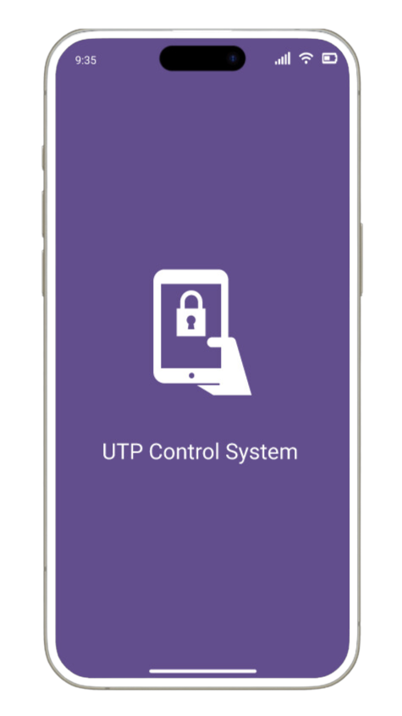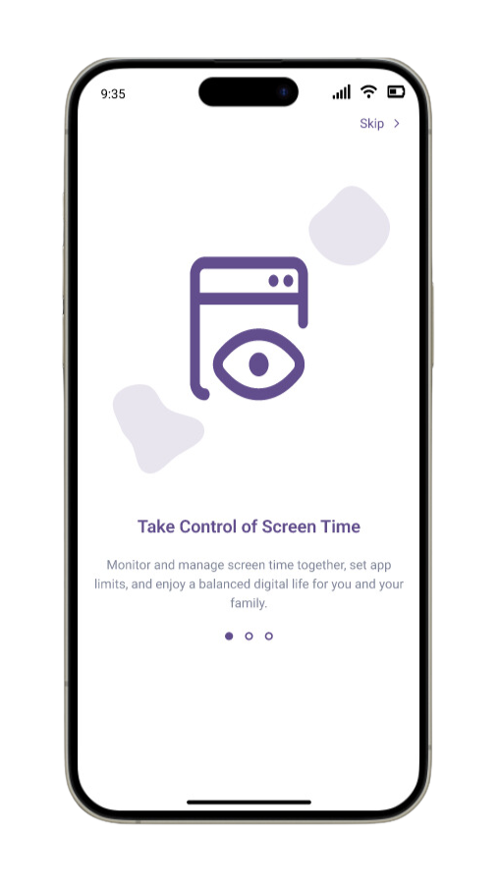

1. **User-Guide Screen (Cont.):**

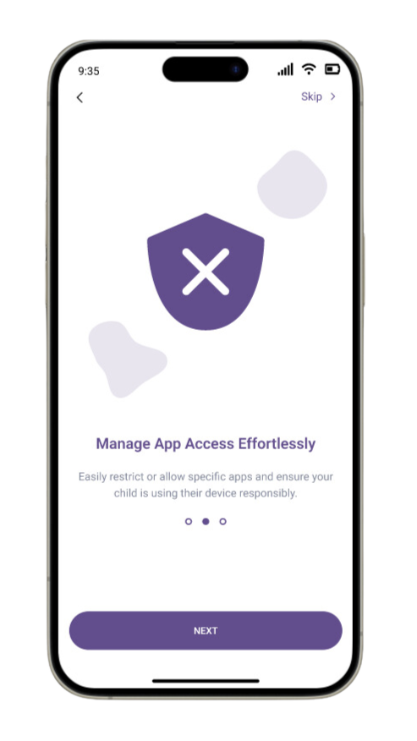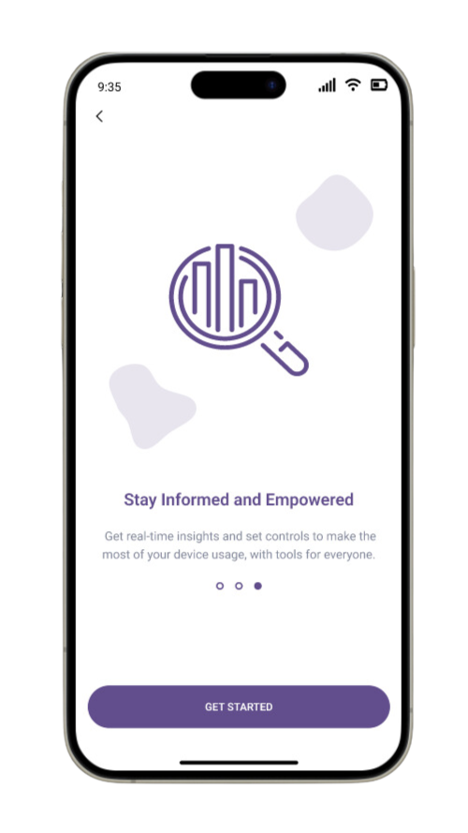

1. **Sign-up and Sign-in Screen:**

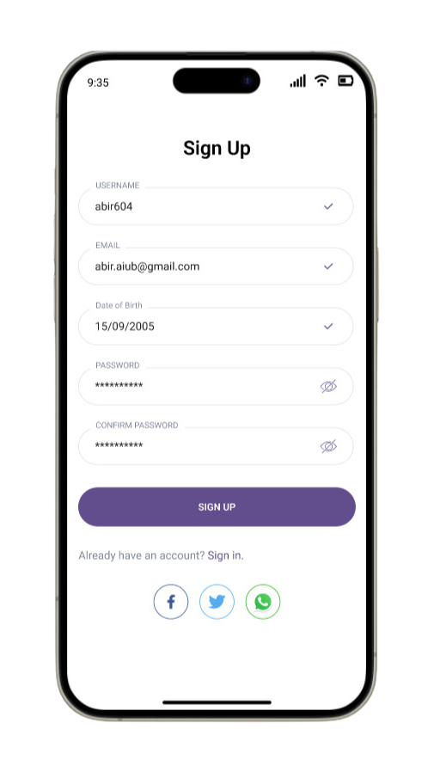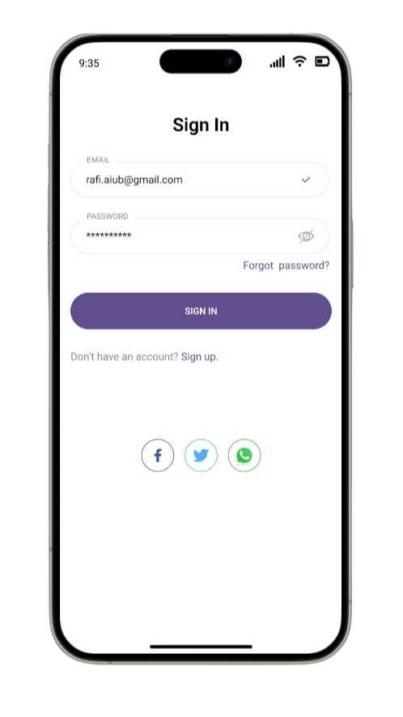

1. **Forget Password and Authentication Screen:**

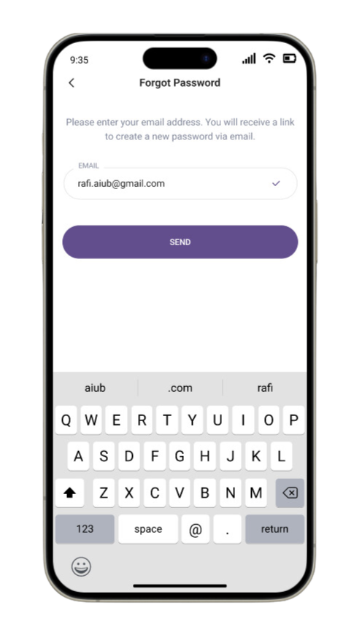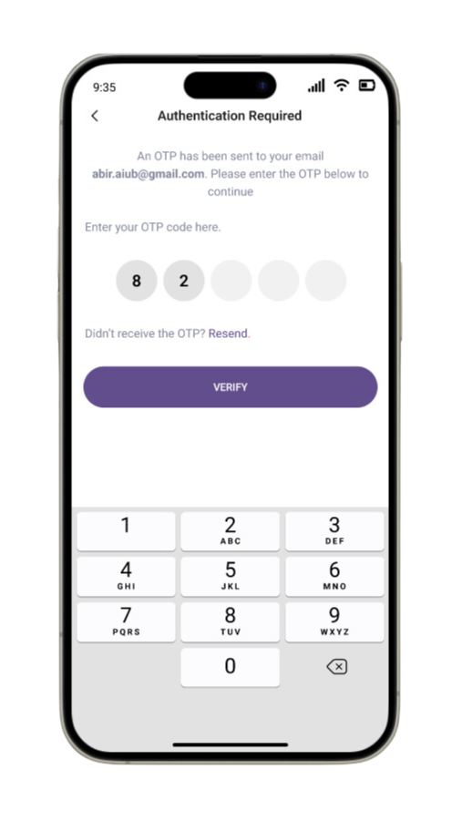

1. **Homepage and Profile Menu Screen:**

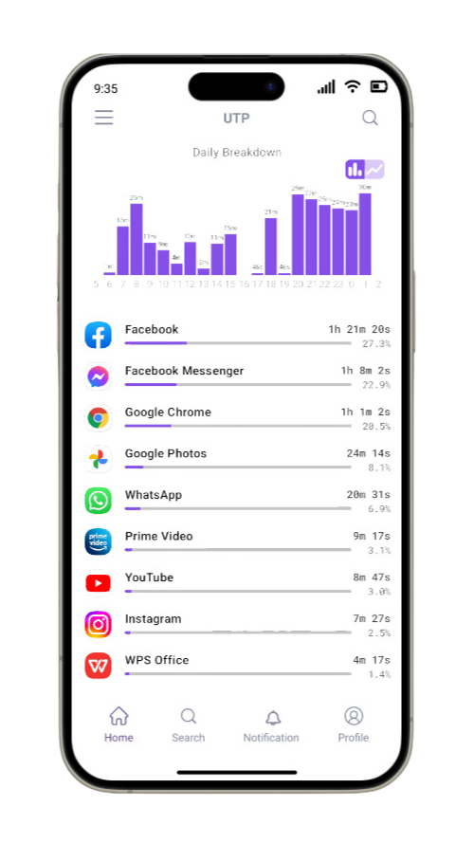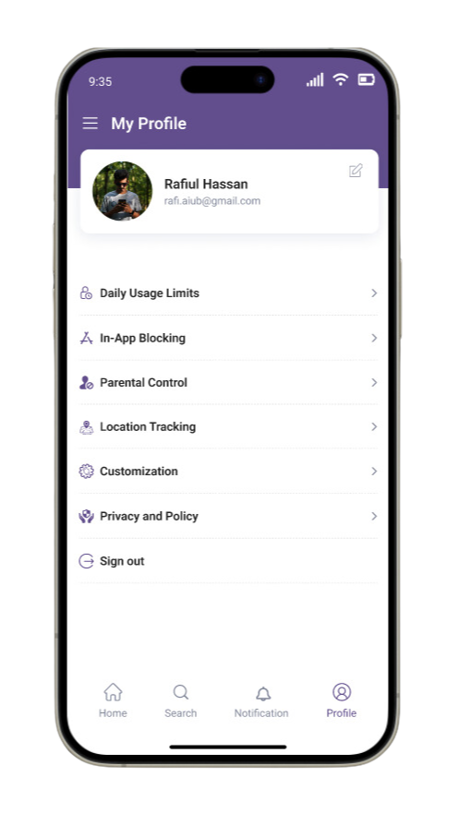

1. **Profile Edit and My Profile Screen:**

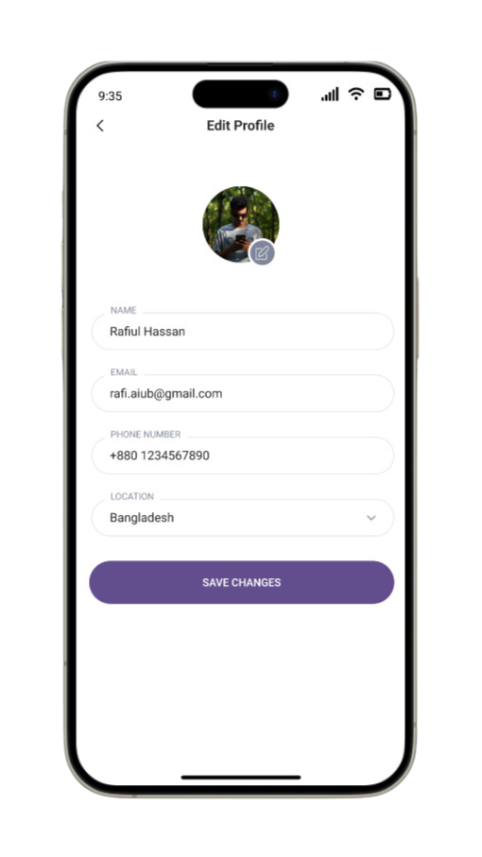

1. **Parental Control System Screen:**

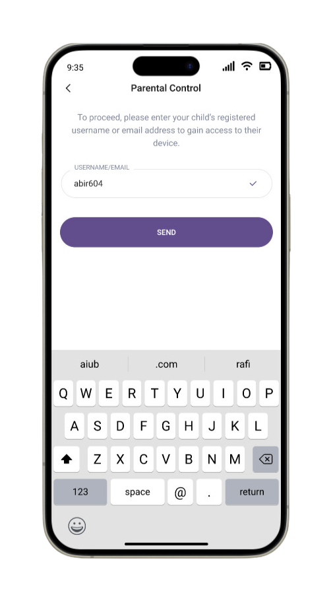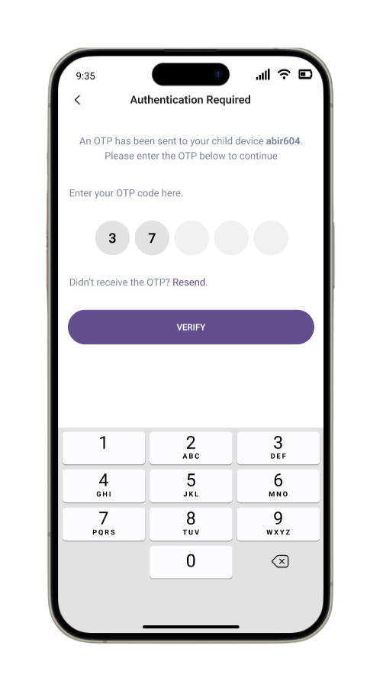

1. **Parental Accessed Screen:**

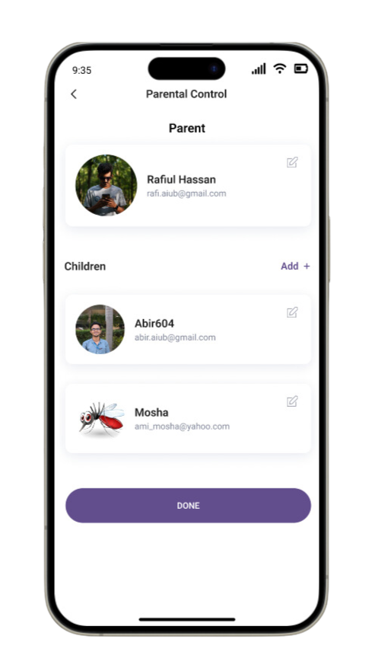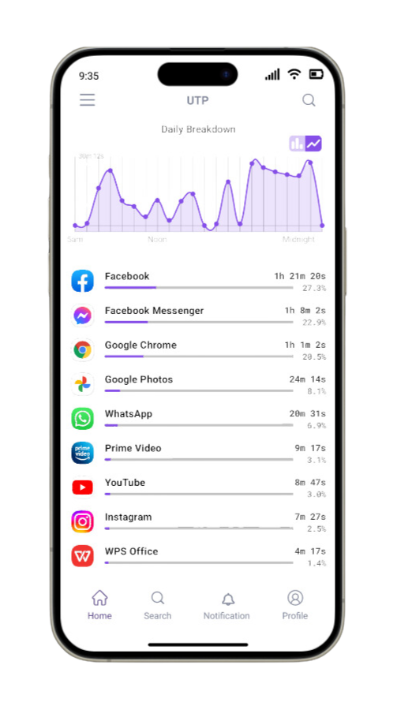

1. **Usage Limits Screen:**

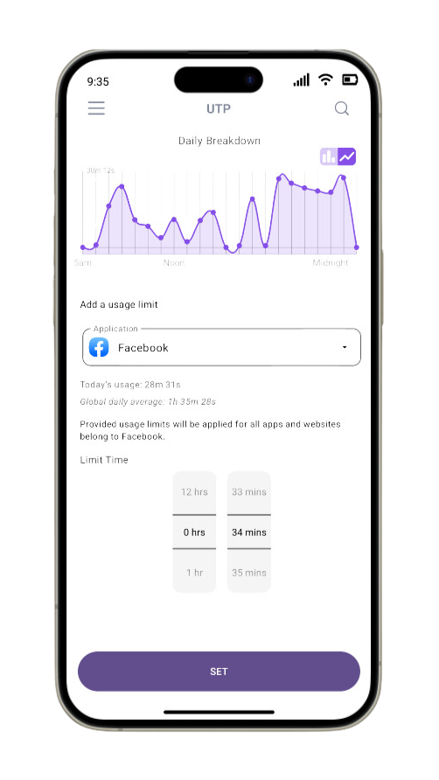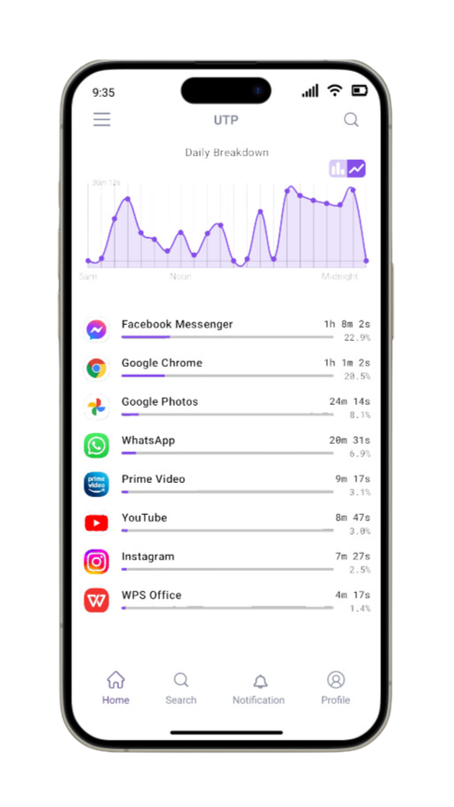

1. **In-App Blocking and Location Tracking Screen :**

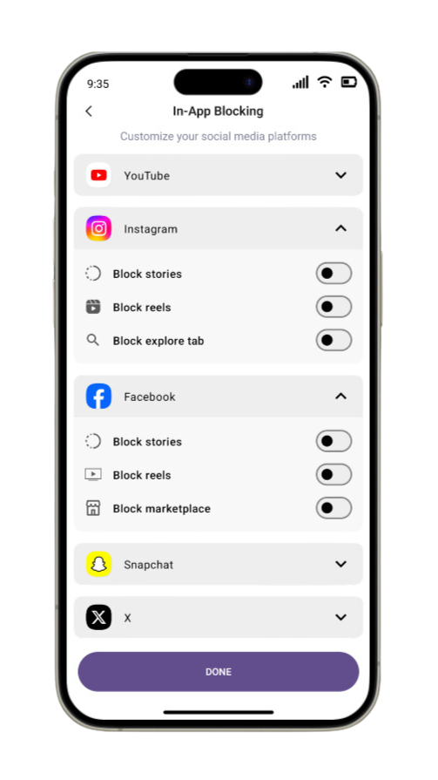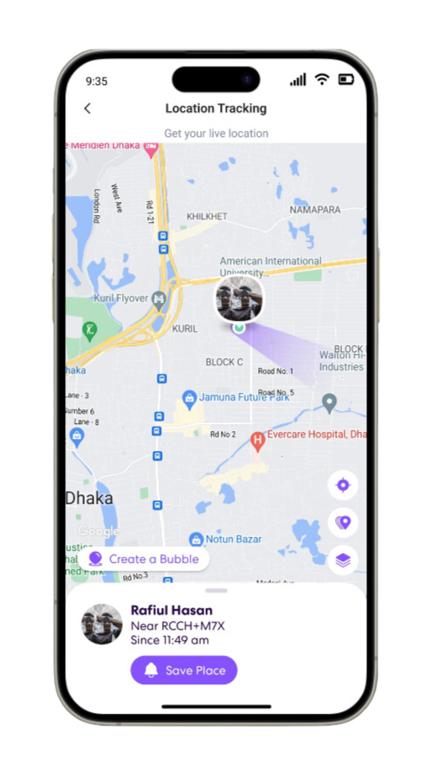

1. **Customization and Privacy-Policy Screen:**

